Hong Kong Institute of Vocational Education
IT114105 HD in Software Engineering
ITP4514 Artificial Intelligence and Machine Learning

Lab 1 – Python Basics

Exercise 1
a) Write a program to check an input is a prime number or not:
Case 1:
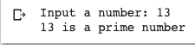

Case 2:
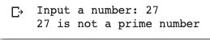

b) Write a Python function chkprime(num) which return True if num is a prime value, otherwise return a False. And then rewrite part (a) to use your function.

c) Write a Python program asks users to input two values which first value is the lower bound and second is the upper bound. And then your program which display all prime numbers between these two values. You must use the function chkprime(num) in part (b).

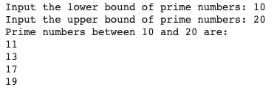

Exercise 2
In Python, you can import random library and then use random.randint(1,100) to get a random integer value between 1 and 100.
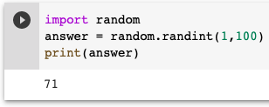
Write a Python program which randomly generate an integer value between 1 to 100, and then ask users to guess this value. You program is required to give hints and also calculate how many steps to guess the value.
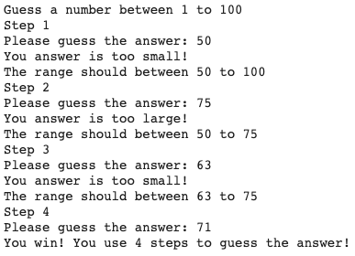

Exercise 3
Write a Python program which can randomly generate a Mathematic Question and then ask player to answer. The operator of this Mathematic Question is one of the +, -, *, / with following requirements:
- Components of a question should have two operands and one operator only, e.g 45 + 3
- Two operands and one operator are RANDOMLY generated by your programme.
- Two operands must be integer.
- The maximum value of operand must be 99.
- Operators are limited to +, -, *, /.
- For division calculation, the answer should be an integer. For example, 23 / 2 is not allowed. Furthermore, 1 is not allowed in division calculation.
- For minus calculation, the answer must be greater than or equal to 0.

Case 1:
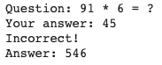

Case 2:
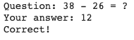

Case 3:
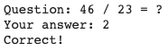

*** End of Lab 1 ***

